Indrawan Saputra

Assignment 6

CPSC 473-01

1. cURL to test the API.

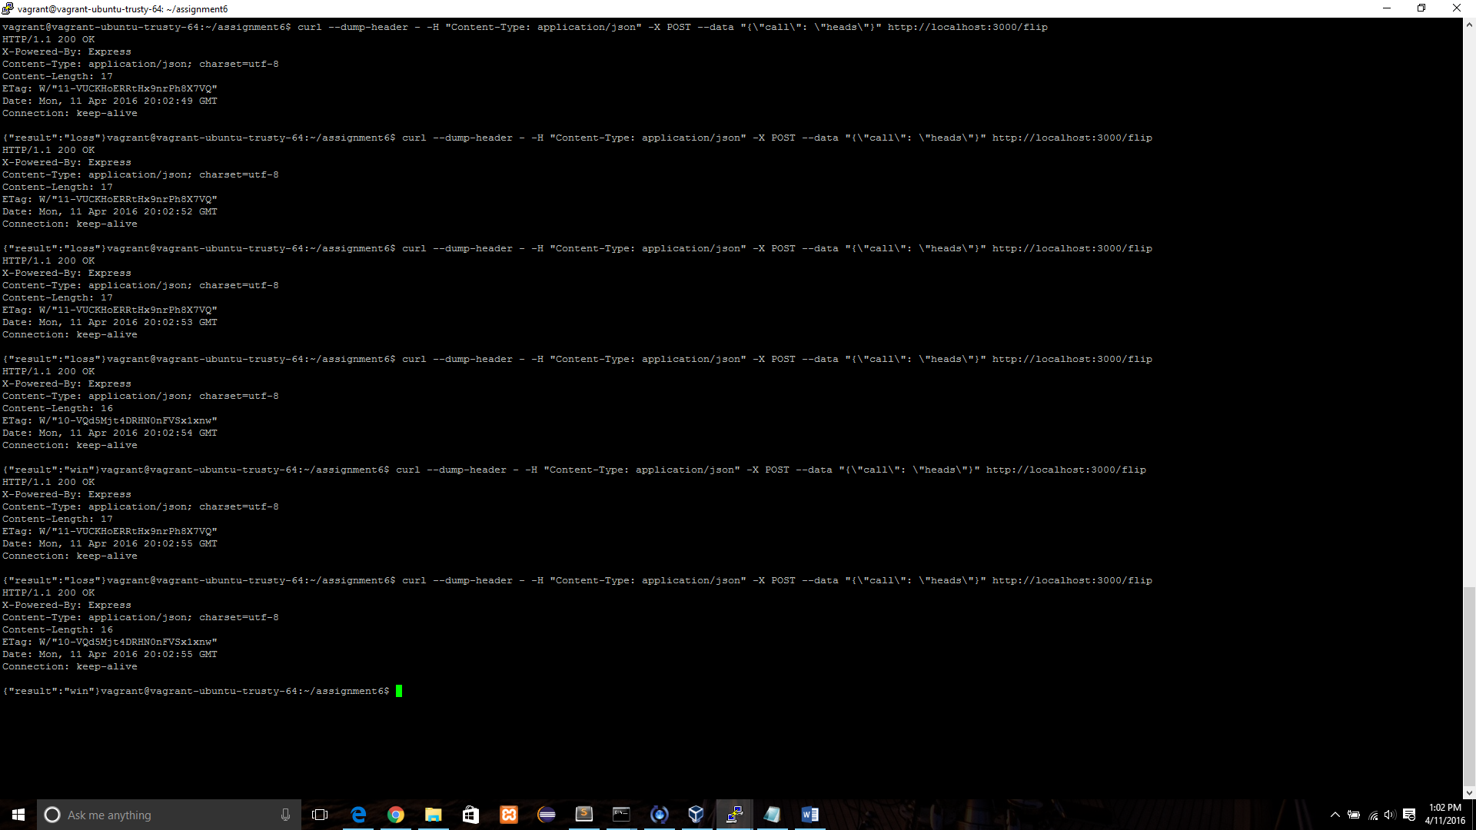

2. Statistic of wins and losses

3. Redis command to check wins and losses in the database.



4. Sending DELETE “stats” to reset the database.



5. Wins and losses reset to 0.

